SMART CALORIE TRACKER
Learning Block 1
Submitted by
GANJI RAKSHITHA
Teegala Krishna Reddy Engineering College
Department of Computer Science and Engineering
Academic Year: Pre-Final– 2026–2027
GitHub link:
Guided by: Raghavendra Rao

CONTENTS
TITLE | PAGE NO
1.Introduction | 1
2.Problem Statement | 1
3.Objectives | 1
4.Project Scope | 1
5.Proposed System/Methodology | 1-2
6.System Architecture/Workflow | 2
7.Implementation | 2-11
8.User Interface/Application Screenshots | 11-14
9.Challenges and Limitations | 15
10.Conclusion | 15
11.Future Scope | 15
12.References | 16

Introduction
The Smart Calorie Tracker is a web-based application designed to simplify daily calorie management. It allows users to create a personal profile, set daily calorie goals, and record the food they consume. The system automatically calculates the user's calorie intake and displays their daily calorie status, helping them monitor their eating habits and track their progress toward their goals. By providing a simple and organized way to manage calorie consumption, the application encourages users to make healthier and more informed food choices.

Problem Statement
Many people find it difficult to calculate and manage their daily calorie requirements accurately. Manual calorie tracking can be time-consuming and may result in calculation errors, making it difficult for users to know how many calories they have consumed and how many remain for the day. Additionally, food information is often stored separately, which makes it challenging to monitor overall progress and maintain consistent eating habits. Therefore, there is a need for a simple, personalized, and user-friendly digital calorie tracking system that can help users manage their daily calorie intake effectively.

Objectives

- To simplify daily calorie tracking.
- To maintain user profile information such as age, height, weight, and activity level.
- To record food items and their calorie values.
- To calculate daily calorie requirements and intake.
- To show remaining or excess calories.
- To monitor progress toward the user's fitness goal.
- To provide simple personalized recommendations

4.Project Scope
The project focuses on developing a basic smart calorie management application that supports user registration, profile management, daily calorie goal calculation, and food tracking. It allows users to monitor calories consumed and remaining, view daily progress, and maintain food and progress history through an easy-to-use dashboard. Future versions may include AI-based food recognition, wearable device integration, and advanced diet planning features.
.

Proposed System / Methodology
The proposed system replaces manual calorie calculation with a digital tracking application.
1. User registers and creates a personal profile.
2. The system determines a suitable daily calorie target.
3. User enters the food consumed during the day.
4. The system calculates and updates total calorie intake.
5. Intake is compared with the daily target.
6. Dashboard displays progress and calorie status.
7. The system stores the user's records for future monitoring.

6. System Architecture / Workflow

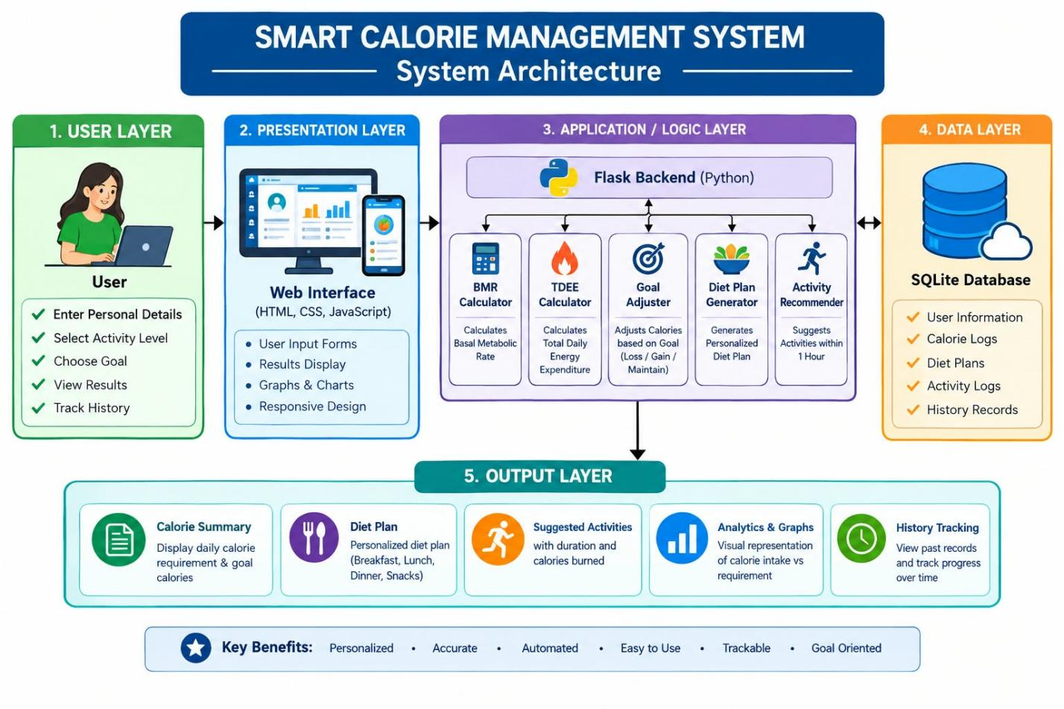

7.Implementation
from flask import Flask, request, redirect, session, render_template_string
import sqlite3
from datetime import datetime
import random

app = Flask(__name__)
app.secret_key = "smart_calorie_secret"
DB = "database.db"

# ============================================================
# DATABASE
# ============================================================
def db():
return sqlite3.connect(DB)

def init_db():
con = db()
con.execute("""CREATE TABLE IF NOT EXISTS users (
id INTEGER PRIMARY KEY AUTOINCREMENT,
username TEXT UNIQUE NOT NULL,
email TEXT NOT NULL,
password TEXT NOT NULL
)""")
con.execute("""CREATE TABLE IF NOT EXISTS logs (
id INTEGER PRIMARY KEY AUTOINCREMENT,
username TEXT NOT NULL,
date TEXT NOT NULL,
calories REAL NOT NULL
)""")
con.commit()
con.close()

init_db()

# ============================================================
# COMMON CSS / HTML
# ============================================================
STYLE = """
<style>
* { box-sizing: border-box; }
body {
margin: 0; font-family: Arial, sans-serif;
background: linear-gradient(135deg, #4facfe, #00f2fe);
min-height: 100vh; color: #222;
}
.container {
width: 90%; max-width: 650px; margin: 45px auto;
background: white; padding: 28px; border-radius: 15px;
box-shadow: 0 8px 25px rgba(0,0,0,.18);
}
h1, h2, h3 { text-align: center; }
h2 { color: #1677c8; }
input, select {
width: 100%; padding: 12px; margin: 7px 0 12px;
border: 1px solid #ccc; border-radius: 7px;
}
button {
width: 100%; padding: 12px; border: 0; border-radius: 7px;
background: #1687e8; color: white; font-size: 16px;
cursor: pointer;
}
button:hover { background: #096ab9; }
a { color: #0876c9; text-decoration: none; }
.nav { text-align: center; margin-top: 20px; }
.card {
background: #f5fbff; padding: 15px; margin: 12px 0;
border-radius: 10px; border-left: 5px solid #1687e8;
}
.result { display: grid; grid-template-columns: repeat(3,1fr); gap: 10px; }
.result .card { text-align: center; border-left: 0; }
.barbox { margin: 18px 0; }
.bar {
height: 30px; color: white; padding: 7px; margin: 7px 0;
border-radius: 5px; background: #1687e8; min-width: 30px;
}
table { width: 100%; border-collapse: collapse; margin-top: 15px; }
th, td { border: 1px solid #ddd; padding: 9px; text-align: center; }
th { background: #1687e8; color: white; }
.error { color: #c62828; text-align: center; }
.success { color: #16843a; text-align: center; }
ul { line-height: 1.8; }
@media(max-width:600px) { .result { grid-template-columns: 1fr; } }
</style>
"""

BASE = """
<!DOCTYPE html>
<html>
<head><title>Smart Calorie Tracker</title>{{ style|safe }}</head>
<body><div class="container">{{ content|safe }}</div></body>
</html>
"""

def page(content):
return render_template_string(BASE, style=STYLE, content=content)

# ============================================================
# LOGIN
# ============================================================
LOGIN = """
<h2>🔐 Smart Calorie Tracker</h2>
<p style='text-align:center'>Login to continue</p>
<form method='POST'>
<input name='username' placeholder='Username' required>
<input name='password' type='password' placeholder='Password' required>
<button type='submit'>Login</button>
</form>
<p class='nav'>New user? <a href='/register'>Create Account</a></p>
"""

@app.route('/')
def home():
return redirect('/login')

@app.route('/login', methods=['GET', 'POST'])
def login():
if request.method == 'POST':
username = request.form['username'].strip()
password = request.form['password']
con = db()
user = con.execute(
"SELECT username FROM users WHERE username=? AND password=?",
(username, password)
).fetchone()
con.close()
if user:
session['user'] = username
return redirect('/dashboard')
return page(LOGIN.replace(
"<p style='text-align:center'>Login to continue</p>",
"<p class='error'>❌ Invalid username or password</p>"
))
return page(LOGIN)

# ============================================================
# REGISTER
# ============================================================
REGISTER = """
<h2>📝 Register</h2>
<form method='POST'>
<input name='username' placeholder='Username' required>
<input name='email' type='email' placeholder='Email' required>
<input name='password' type='password' placeholder='Password' required>
<button type='submit'>Register</button>
</form>
<p class='nav'>Already have an account? <a href='/login'>Login</a></p>
"""

@app.route('/register', methods=['GET', 'POST'])
def register():
if request.method == 'POST':
username = request.form['username'].strip()
email = request.form['email'].strip()
password = request.form['password']
try:
con = db()
con.execute(
"INSERT INTO users(username,email,password) VALUES(?,?,?)",
(username, email, password)
)
con.commit()
con.close()
return redirect('/login')
except sqlite3.IntegrityError:
return page(REGISTER.replace(
'<h2>📝 Register</h2>',
"<h2>📝 Register</h2><p class='error'>⚠ Username already exists</p>"
))
return page(REGISTER)

# ============================================================
# DASHBOARD
# ============================================================
FORM = """
<h2>🥗 Smart Calorie Management</h2>
<p style='text-align:center'>Welcome, <b>{{ user }}</b></p>
<form action='/result' method='POST'>
<label>Weight (kg)</label>
<input type='number' name='weight' min='1' step='0.1' required>

<label>Height (cm)</label>
<input type='number' name='height' min='1' step='0.1' required>

<label>Age</label>
<input type='number' name='age' min='1' max='120' required>

<label>Gender</label>
<select name='gender'>
<option value='male'>Male</option>
<option value='female'>Female</option>
</select>

<label>Activity Level</label>
<select name='activity'>
<option value='1.2'>Sedentary - little exercise</option>
<option value='1.375'>Lightly Active</option>
<option value='1.55'>Moderately Active</option>
<option value='1.725'>Very Active</option>
<option value='1.9'>Extra Active</option>
</select>

<label>Goal</label>
<select name='goal'>
<option value='loss'>Weight Loss</option>
<option value='maintain'>Maintain Weight</option>
<option value='gain'>Weight Gain</option>
</select>

<button type='submit'>Calculate Calories</button>
</form>
<div class='nav'>
<a href='/history'>📅 History</a> &nbsp;|&nbsp;
<a href='/logout'>🚪 Logout</a>
</div>
"""

@app.route('/dashboard')
def dashboard():
if 'user' not in session:
return redirect('/login')
return render_template_string(
BASE, style=STYLE,
content=render_template_string(FORM, user=session['user'])
)

# ============================================================
# CALORIE CALCULATION
# ============================================================
def calculate_calories(weight, height, age, gender, activity, goal):
# Mifflin-St Jeor BMR formula
if gender == 'female':
bmr = (10 * weight) + (6.25 * height) - (5 * age) - 161
else:
bmr = (10 * weight) + (6.25 * height) - (5 * age) + 5

tdee = bmr * activity

if goal == 'loss':
calories = tdee - 500
elif goal == 'gain':
calories = tdee + 500
else:
calories = tdee

return max(1200, bmr), tdee, max(1200, calories)

# ============================================================
# RESULT
# ============================================================
RESULT = """
<h2>🎯 Your Calorie Report</h2>
<div class='result'>
<div class='card'><b>BMR</b><br>{{ bmr }} kcal</div>
<div class='card'><b>TDEE</b><br>{{ tdee }} kcal</div>
<div class='card'><b>Daily Goal</b><br>{{ calories }} kcal</div>
</div>

<h3>📊 Calorie Comparison</h3>
<div class='barbox'>
<b>BMR</b><div class='bar' style='width:{{ bmr_width }}%'>{{ bmr }}</div>
<b>TDEE</b><div class='bar' style='width:{{ tdee_width }}%'>{{ tdee }}</div>
<b>Goal</b><div class='bar' style='width:{{ cal_width }}%'>{{ calories }}</div>
</div>

<h3>🥗 Personalized Diet Plan</h3>
<div class='card'>
<ul>{% for item in diet %}<li>{{ item }}</li>{% endfor %}</ul>
</div>

<h3>🔥 Suggested 1-Hour Activities</h3>
<div class='card'>
<ul>{% for item in activities %}<li>{{ item }}</li>{% endfor %}</ul>
</div>

<p class='success'>✅ Today's calorie result has been saved.</p>
<div class='nav'>
<a href='/dashboard'>⬅ Back</a> &nbsp;|&nbsp;
<a href='/history'>📅 History</a> &nbsp;|&nbsp;
<a href='/logout'>🚪 Logout</a>
</div>
"""

@app.route('/result', methods=['POST'])
def result():
if 'user' not in session:
return redirect('/login')

try:
weight = float(request.form['weight'])
height = float(request.form['height'])
age = int(request.form['age'])
gender = request.form['gender']
activity = float(request.form['activity'])
goal = request.form['goal']
except (ValueError, KeyError):
return page("<h2>❌ Please enter valid details.</h2><div class='nav'><a href='/dashboard'>Back</a></div>")

bmr, tdee, calories = calculate_calories(
weight, height, age, gender, activity, goal
)

breakfasts = ['Idli + Sambar', 'Oats + Banana', 'Eggs + Bread', 'Upma + Fruit']
lunches = ['Rice + Dal + Vegetables', 'Chapati + Paneer', 'Chicken + Rice', 'Rice + Sambar']
dinners = ['Chapati + Vegetables', 'Soup + Toast', 'Khichdi + Curd', 'Rice + Dal']
snacks = ['Fruits', 'Nuts', 'Sprouts', 'Yogurt']

diet = [
'Breakfast: ' + random.choice(breakfasts),
'Lunch: ' + random.choice(lunches),
'Dinner: ' + random.choice(dinners),
'Snacks: ' + random.choice(snacks)
]

if goal == 'loss':
diet.append('Tip: Reduce fried foods and sugary drinks; drink enough water.')
elif goal == 'gain':
diet.append('Tip: Include protein-rich foods, milk, nuts and healthy calories.')
else:
diet.append('Tip: Maintain a balanced diet with vegetables, protein and whole grains.')

activities = [
'Walking - 1 hour, about 200-250 kcal',
'Jogging - 1 hour, about 400 kcal',
'Cycling - 1 hour, about 450 kcal',
'Skipping - 1 hour, about 500 kcal',
'Yoga - 1 hour, improves flexibility and fitness'
]

today = datetime.now().strftime('%Y-%m-%d')
con = db()
con.execute(
'INSERT INTO logs(username,date,calories) VALUES(?,?,?)',
(session['user'], today, calories)
)
con.commit()
con.close()

maximum = max(bmr, tdee, calories)
bmr_width = max(5, round(bmr / maximum * 100))
tdee_width = max(5, round(tdee / maximum * 100))
cal_width = max(5, round(calories / maximum * 100))

content = render_template_string(
RESULT,
bmr=round(bmr, 2),
tdee=round(tdee, 2),
calories=round(calories, 2),
bmr_width=bmr_width,
tdee_width=tdee_width,
cal_width=cal_width,
diet=diet,
activities=activities
)
return page(content)

# ============================================================
# HISTORY
# ============================================================
HISTORY = """
<h2>📅 Calorie History</h2>
<p style='text-align:center'>User: <b>{{ user }}</b></p>
{% if data %}
<table>
<tr><th>Date</th><th>Calories</th></tr>
{% for row in data %}
<tr><td>{{ row[0] }}</td><td>{{ row[1]|round(2) }} kcal</td></tr>
{% endfor %}
</table>
{% else %}
<p style='text-align:center'>No calorie records found.</p>
{% endif %}
<div class='nav'>
<a href='/dashboard'>⬅ Dashboard</a> &nbsp;|&nbsp;
<a href='/logout'>🚪 Logout</a>
</div>
"""

@app.route('/history')
def history():
if 'user' not in session:
return redirect('/login')
con = db()
data = con.execute(
'SELECT date, calories FROM logs WHERE username=? ORDER BY id DESC',
(session['user'],)
).fetchall()
con.close()
return page(render_template_string(HISTORY, user=session['user'], data=data))

# ============================================================
# LOGOUT AND START
# ============================================================
@app.route('/logout')
def logout():
session.clear()
return redirect('/login')

if __name__ == '__main__':
app.run(debug=True)

Recommendation Screen – provides simple suggestions based on calorie status.

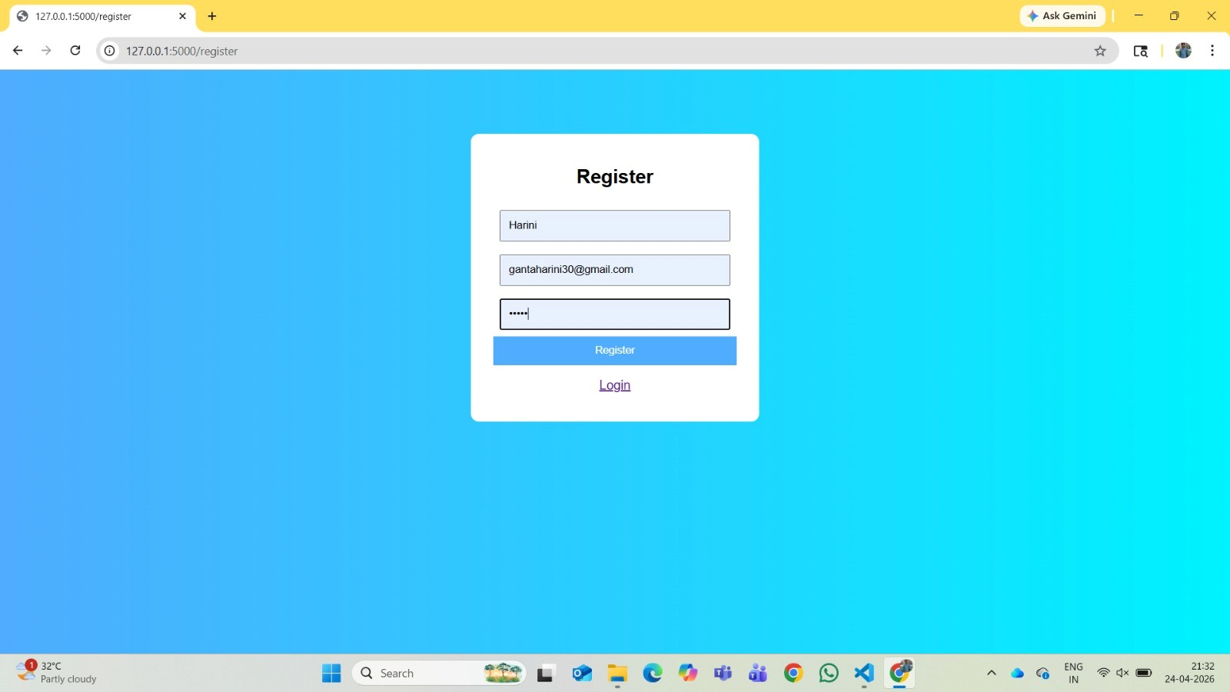

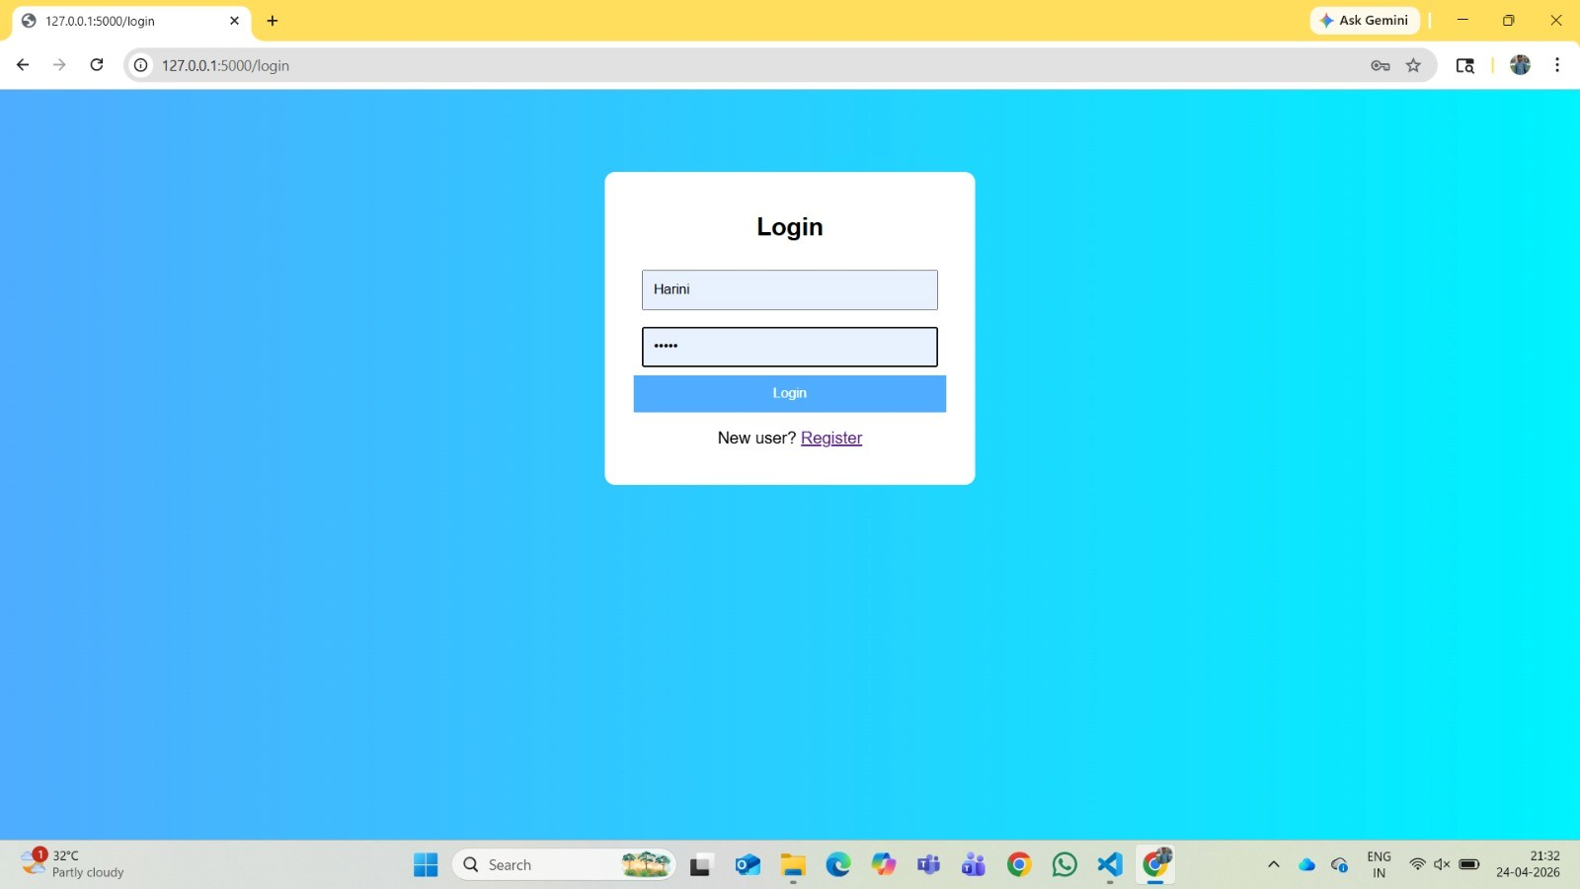

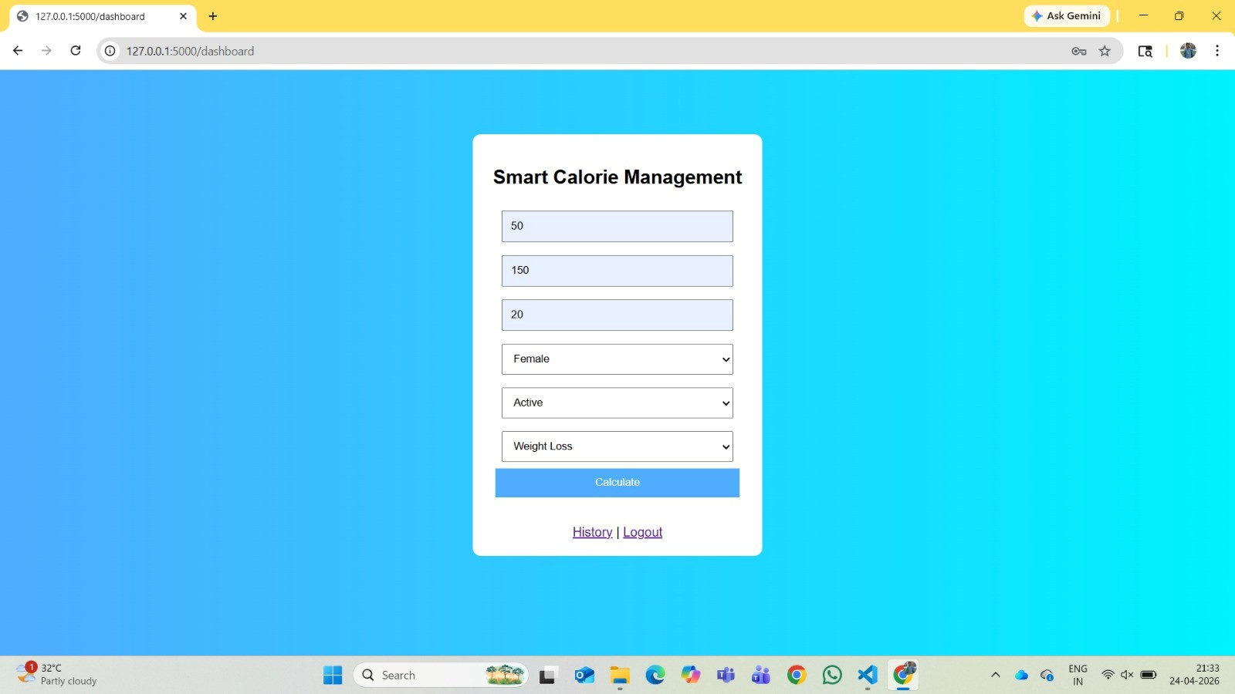

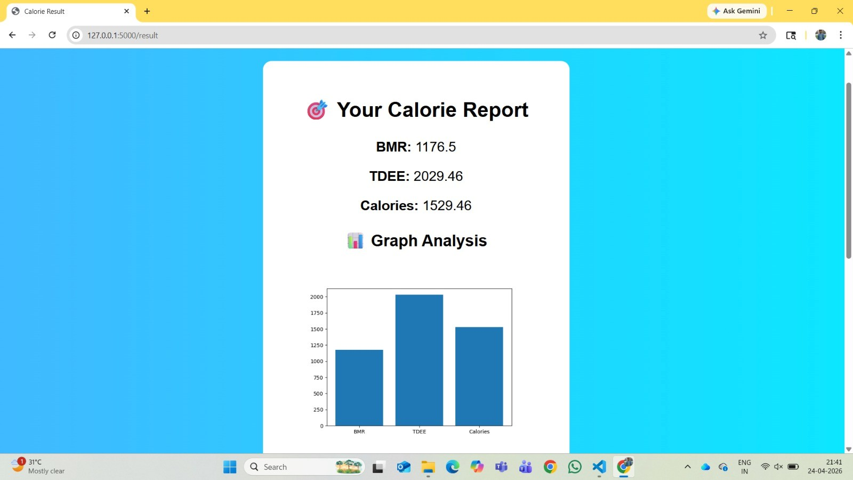

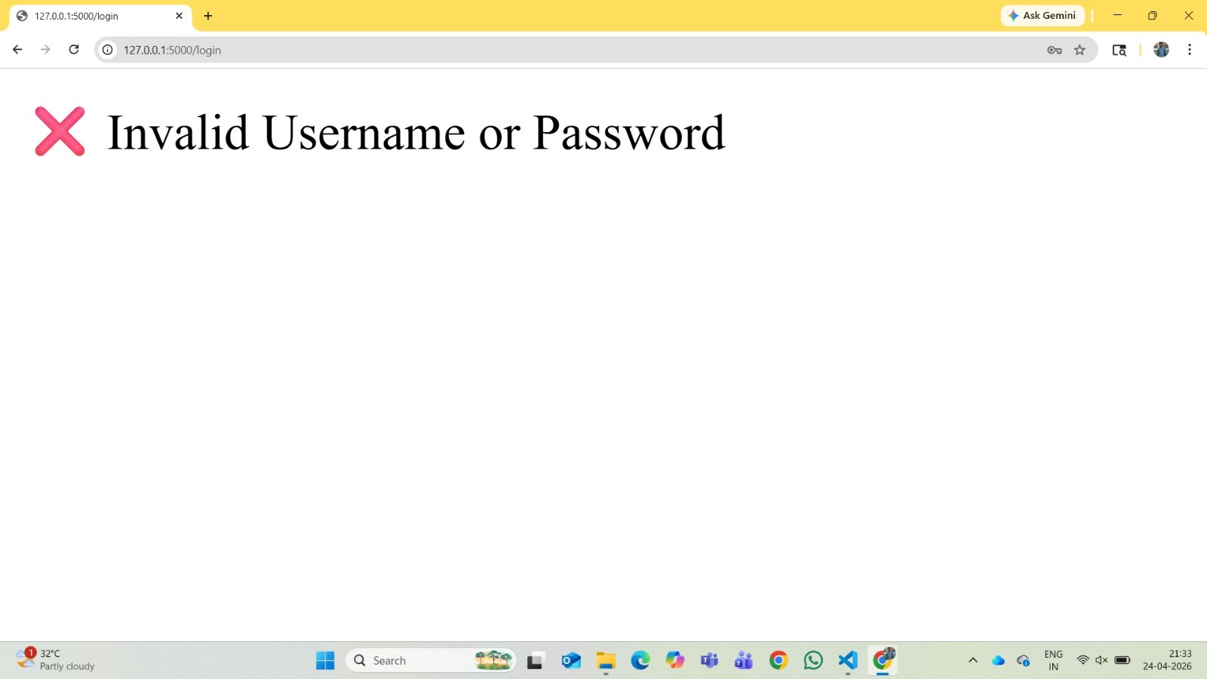

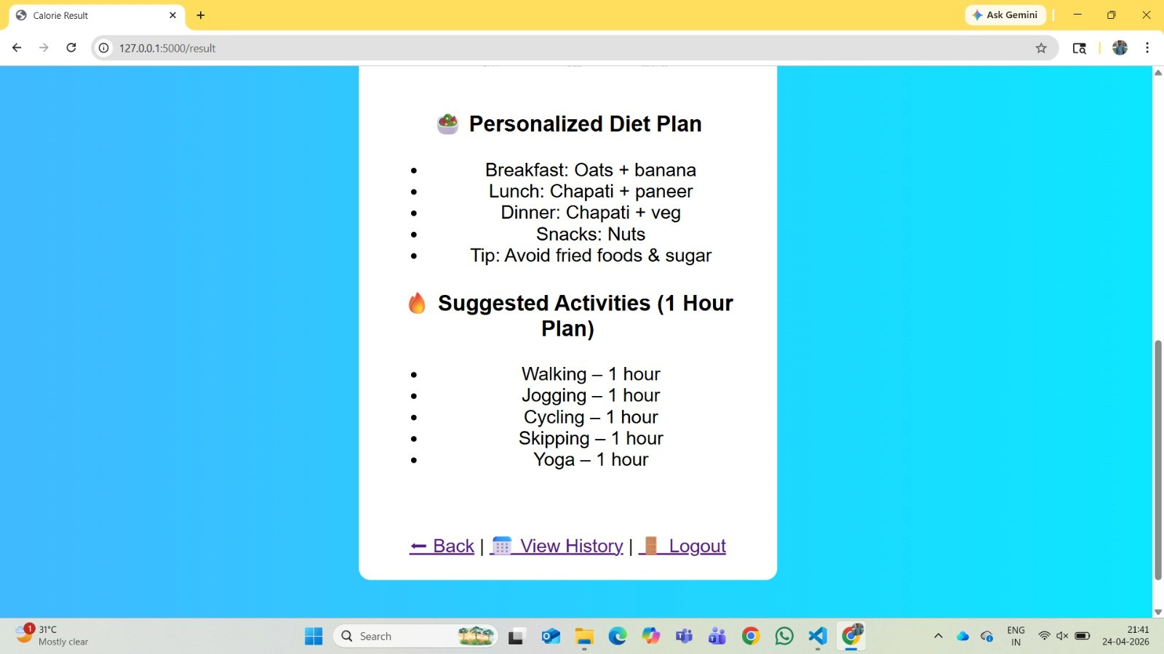

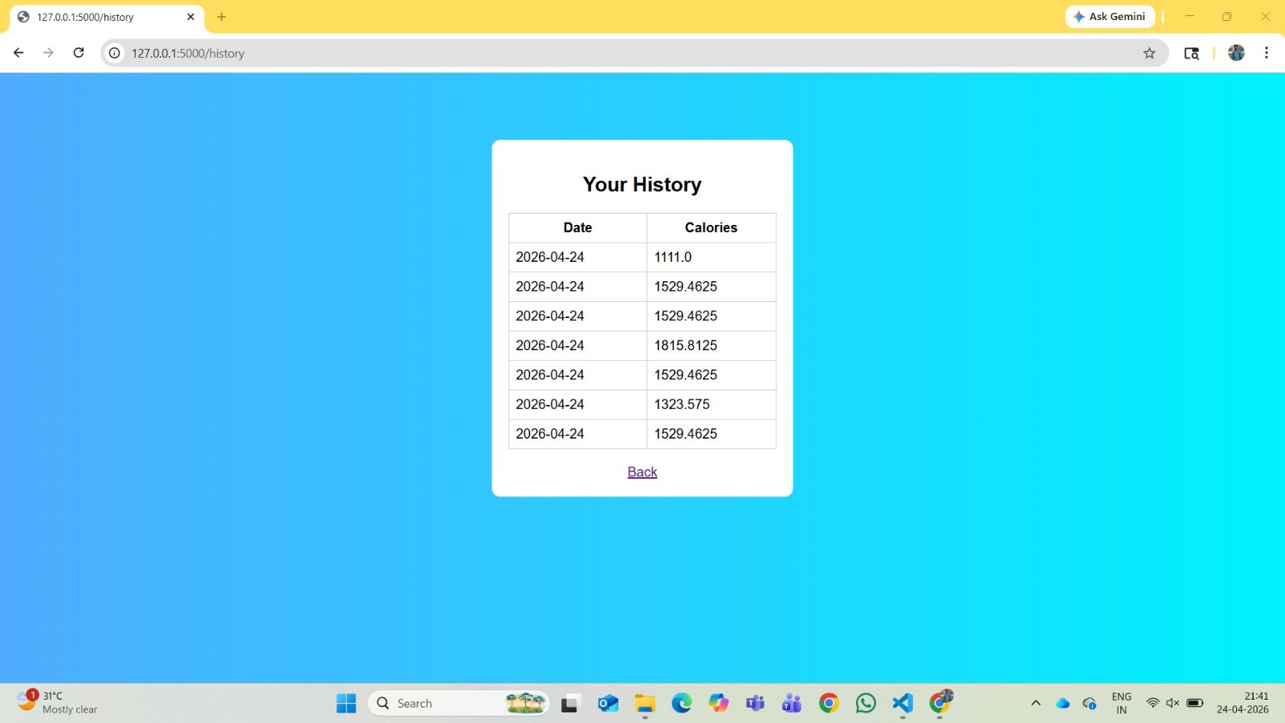

9. Challenges and Limitations

Challenges
- .Designing a simple and user-friendly calorie dashboard.
- • Maintaining accurate food calorie information.
- • Calculating personalized calorie targets.
- • Managing daily food and progress records.
- • Providing useful recommendations.

Limitations
- Calorie values may depend on the accuracy of the food database.
- The basic version may not recognize food automatically from images.
- Advanced medical or dietician-level advice is outside the scope of the basic system

Conclusion
The Smart Calorie Tracker provides a simple and efficient way to manage daily calorie intake.
It combines user profiles, calorie tracking, analysis, dashboard visualization and recommendations.
The system reduces manual calculation and helps users understand their eating habits.
It provides a foundation for developing more advanced AI-based nutrition and fitness applications.

Future Scope
AI-based food recognition using images.
Voice-based food entry.
Integration with smart watches and fitness bands.
Personalized meal planning.
Exercise and calorie-burn tracking.
AI-powered nutrition recommendations.
Cloud database and multi-device synchronization.
Mobile application support.

12. References

- MDN Web Docs – HTML, CSS and JavaScript documentation.
- Python Documentation – Python programming language.
- Django Documentation – Web framework documentation.
- MySQL / SQLite Documentation – Database references.
- Google AI for Developers – AI and machine learning resources

